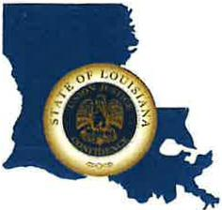 | CAPITAL AREA GROUNDWATER CONSERVATION DISTRICT
GARY I. BEARD
EXECUTIVE DIRECTOR

MEETING NOTICE
Capital Area Groundwater Conservation District
Board Meeting

WHEN: Thursday, June 15, 2023

TIME: 1:00 p.m.

WHERE: Renaissance Baton Rouge Hotel
7000 Bluebonnet Blvd.
Baton Rouge, Louisiana. 70810

Contact Person: Lisa Manda, (225)293-7370

